**Fading Channels & Mobile Communications**

**IIT Kharagpur**

**Date: 8 Oct 2018**

**Exp 2: Understanding of Path Loss & Shadowing**

**Name: MOHIT KAPOOR**

**__________________________________________________________**

|  |  |  |  |  |  |  |  |  |  |
| --- | --- | --- | --- | --- | --- | --- | --- | --- | --- |
| **URBAN MICRO** | |  | **Power Recieved (dBm) vs . Distance (m)** | | | | | | |
| **Pr(dBm)** | **Dist(m)** |  |  |  |  |  |  |  |  |
| 6.33 | 105.0 | **(dBm)** | 5 |  |  |  |  |  |  |
| -1.78 | 115.0 |  |  |  |  |  |  |  |
|  |  |  |  |  |  |  |  |
| -7.97 | 125.0 |  | 0 |  |  |  |  |  |  |
| 2.29 | 135.0 |  |  |  |  |  |  |  |  |
| -4.9 | 145.0 | **Recieved** | - 5 |  |  |  |  |  |  |
| -25.96 | 155.0 |  |  |  |  |  |  |  |
|  |  |  |  |  |  |  |  |
| -13.89 | 165.0 |  | -10 |  |  |  |  |  |  |
| -19.84 | 175.0 |  |  |  |  |  |  |  |
|  |  |  |  |  |  |  |  |
| -16.66 | 185.0 |  | -15 |  |  |  |  |  |  |
| 0.91 | 195.0 |  |  |  |  |  |  |  |
|  |  |  |  |  |  |  |  |
| -20.01 | 205.0 | **Power** | -20 |  |  |  |  |  |  |
| -21.64 | 215.0 |  |  |  |  |  |  |
|  |  |  |  |  |  |  |
| -24.43 | 225.0 |  |  |  |  |  |  |  |  |
| -29.95 | 235.0 |  | -25 |  |  |  |  |  |  |
| -24.27 | 245.0 |  |  |  |  |  |  |  |  |
| -23.08 | 255.0 |  | -30 |  |  |  |  |  |  |
| -25.46 | 265.0 |  |  |  |  |  |  |  |
|  |  |  |  |  |  |  |  |
| -21.68 | 275.0 |  | 125 | 150 | 175 | 200 | 225 | 250 | 275 |
| -13.14 | 285.0 |  |
|  |  |  | **D i s t a n c e ( m )** | | |  |  |
| -13.41 | 295.0 |  |  |  |  |  |
| Entered | Actual Value | Power Recieved(Entered Value) | | | |  | Measured Power | |  |
| Value |  |  |  |
| n: 4.3 | 4.53 | Calculated Power | |  |  |  |  |  |  |
| sigma: 8 | 7.62 |  |  |  |  |  |  |  |  |

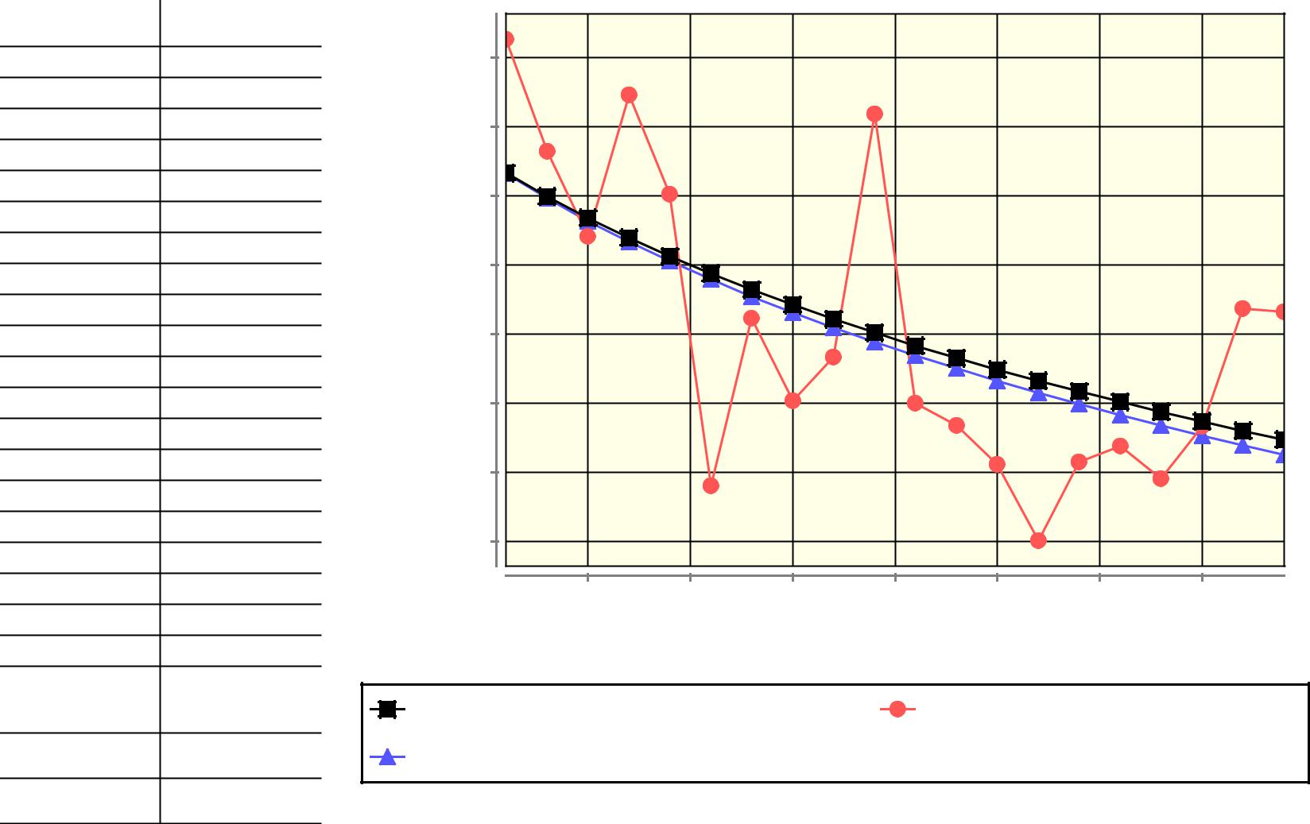

**DISCUSSION:**

(Signature of MOHIT KAPOOR)

(Signature of Faculty)